Faculty VII – Economics and Management
Institute of Technology and Management (ITM)
Department of Trust in Digital Services

TITLE OF THESIS

Bachelor/Master Thesis

[Full name]
[Student ID]

First supervisor: Prof. Dr. Timm Teubner
Second supervisor: Full name

Month xxth, 202X

Declaration of Authorship
(Please use the currently valid version of your responsible examination office.)
I hereby declare to the Faculty VII of the Technische Universität Berlin that this thesis was written independently and only with the help of the indicated sources and aids. All passages in the thesis which have been taken from other works in terms of wording or meaning are marked. This thesis has not been used for any other academic record yet nor has it been submitted to any other institution.

Title of thesis

Author(s)*
Last Name |  | First Name |  | Student ID
Supervisor
Last Name |  | First Name

With my signature, I confirm that I have been informed about the usual citation rules. The customary citation rules of the department have been complied.
A screening for plagiarism with the help of electronic aids can be carried out.
Place, Date |  | Signature(s)**
*For group works, all signatures of all authors are necessary.
**By signing this document, you are accountable for the full content of the final version of this thesis.

Table of Contents

Declaration of Authorship ii
Table of Contents iii
List of Abbreviations v
List of Figures vi
List of Tables vii
1. Introduction 1
1.1. Structure 1
1.2. Creating headings 1
1.3. Updating directories 2
1.4. Including figures 2
1.5. Creating tables 3
1.6. Inserting references 4
1.7. Including footnotes 5
1.8. Defining abbreviations 5
2. Literature 7
2.1. Section 1 7
2.1.1. Subsection 1 7
3. Methodology 8
3.1. Section 1 8
3.2. Section 2 8
4. Results 9
4.1. Section 1 9
4.2. Section 2 9
4.3. Section 3 9
4.4. Section 4 9
5. Discussion 10
6. Conclusion 10
Appendices 12
First Appendix Section 12
References 13

List of Abbreviations

NATO
North Atlantic Treaty Organization.
OLM
Online Labor Market.
WOM
Word of Mouth.

List of Figures
Figure 1: Formatting styles 2
Figure 2: Update Table of Contents 2
Figure 3: Creating a caption for figures 3
Figure 4: Examplary picture of Google 3
Figure 5: Creating a caption for tables 4
Figure 6: Mendely literature database 4
Figure 7: Inserting citations with Mendeley add-on for word 5
Figure 8: Introducing a new abbrevation 6

List of Tables
Table 1: Examplary table 4

Introduction
This is an introduction to this document template. There are many features that can make writing your thesis much easier and are explained in the following (Word 2010-2019).

Structure
The structure of a thesis is (roughly) as follows:
- Introduction (10 %)
  - Motivation, research question, structure of thesis
- Literature (20 %)
  - Relevant literature, theoretical background
- Methodology (20 %)
  - Description of procedure, data, methods
- Results (30 %)
  - Analysis and results
- Discussion (10 %)
  - Interpretation, implications, limitations, further research
- Conclusion and outlook (10 %)
  - Concluding statement, addressee: "Olaf Scholz"
The above-mentioned percentages are only approximate guidelines for the individual chapters. You should discuss the exact structure and length of chapters with your supervisor. Sticking to the introduced general structure helps to improve readability and consistency of your thesis.

Creating headings
The table of content only works properly if you always use the formatting templates for headings, subheadings, etc.
If you want to create a heading, write it in an empty line. Now mark the heading completely and select the respective template in the 'Home' tab in the section ‘Styles’ (depending on the type of heading this is 'Chapter', 'Section-Heading', 'Subsection-Heading etc.).
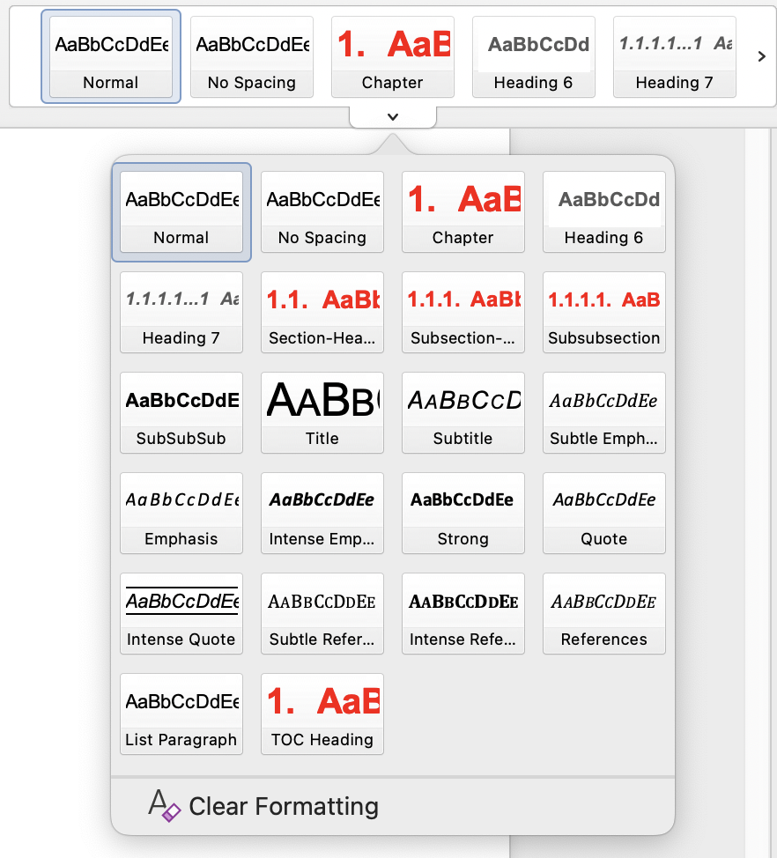
Figure 1: Formatting styles

The table of content will display the new heading when it is updated (see next point: update directories).

Updating directories
All directories (table of content, list of figures, list of tables, list of abbreviations and table of contents) can be updated quickly.
Mark the whole text (Strg+a) and then press ‚F9‘. Choose ‘update entire table‘ and confirm with ‘OK‘.
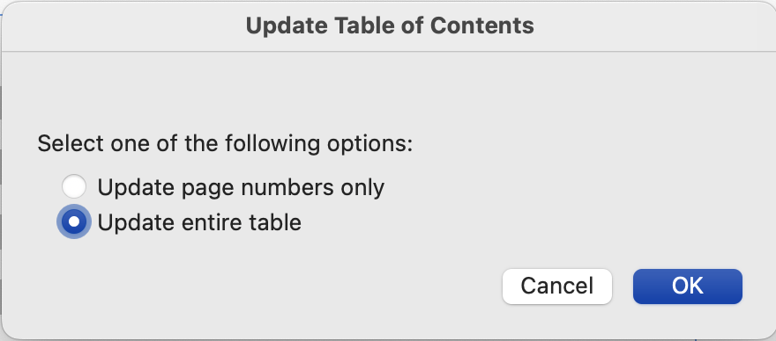
Figure 2: Update Table of Contents

Including figures
To include a figure, choose ‘pictures’ in the tab ‘insert’. Select the picture in a file and click ‘insert’ to confirm. Now center the picture with ‘Strg+e’ and add a caption by clicking ‚insert caption‘ in the section ‚references‘.
First, select all options as shown here and enter your own text instead of *Figure caption*. If the label option 'Figure' does not exist, you can create one with the option 'New label...'.
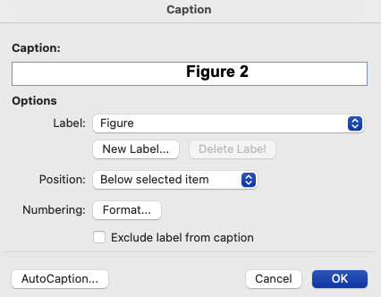
Figure 3: Creating a caption for figures
If necessary, center the caption. After updating all references in the document (see: update all directories), the figure will appear with the respective page number in the list of figures.
Figure 4: Examplary picture of Google

Creating tables
To insert a table, select the 'Table' button in the 'Insert' tab. Create and edit your table according to your wishes.
Now select the entire table (icon when moving the cursor over the upper left corner) and center it (Ctrl+e). In the 'References' tab, select the 'Insert Label' button.
First, select all options as shown here and enter your own text instead of *table label*. If the label option 'Table' does not exist, you can create one with 'New Label...'.
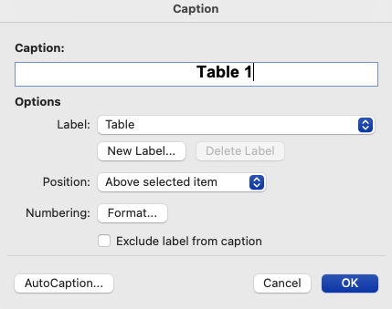
Figure 5: Creating a caption for tables
Table 1: Examplary table
First column | Second column

After updating all references in the document (see: update all directories), the table will appear with its page number in the list of tables.

Inserting references
To insert literature references, we recommend using the free literature management software Mendeley (see Figure 6). Before a literature reference can be added into the text document, it must be included to the database of the selected software. Oftentimes, it is possible to add literature with one click on the journal web page or the function ‘literature search’.
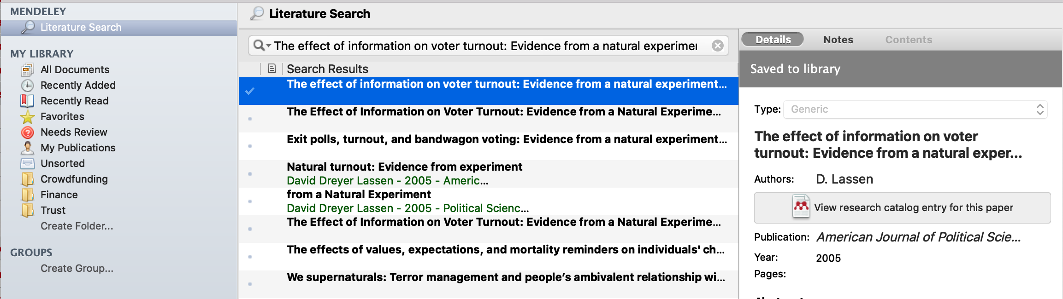
Figure 6: Mendely literature database
By clicking on 'Insert or Edit Citation' you can insert the references from the Mendeley database into the text as a citation. You can choose from a variety of different citation styles. Generally, the Harvard citation style is recommended. Example:
(Teubner 2016: 10)
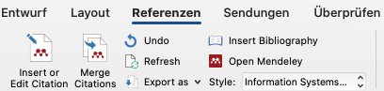
Figure 7: Inserting citations with Mendeley add-on for word
The reference list can be added to the document with Mendeley by clicking ('Insert Bibliography'). Again, the formatting varies depending on the selected style. Please choose the style "MIS Quarterly".

Including footnotes
The use of footnotes is generally not recommended. If, in exceptional cases, it is necessary, move the cursor to the respective text passage. Select the option 'Insert footnote' in the 'References' tab. Now, the text corresponding to the footnote can be entered below the document.
Footnotes are automatically numbered correctly and displayed on the correct page.
Here is an example:
This is a footnote.

Defining abbreviations
Abbreviations should always be listed when familiarity with these cannot be assumed as general knowledge. This can be checked by looking up whether the abbreviation can be found in a dictionary. Thus, neither 'e.g.,' nor 'i.e.,' need be included in the list of abbreviations. OLM
When introducing a new abbreviation, highlight the abbreviation (with a period, if necessary) and select the 'Mark entry' field in the 'References' tab. Select the options as shown here and click 'Set', then 'Close'.
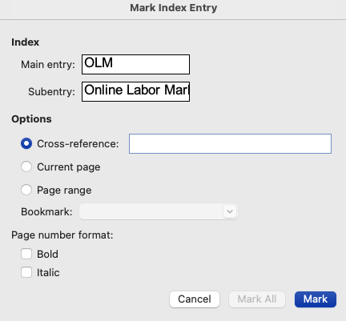
Figure 8: Introducing a new abbrevation
Once all directories have been updated (see: update all directories), the abbreviation will appear in a clear arrangement in the list of abbreviations.
Some examples:
OLM
WOM
NATO

Literature
Lorem ipsum dolor sit amet, consectetuer adipiscing elit. Maecenas porttitor congue massa. Fusce posuere, magna sed pulvinar ultricies, purus lectus malesuada libero, sit amet commodo magna eros quis urna.

Section 1
Lorem ipsum dolor sit amet, consectetuer adipiscing elit. Maecenas porttitor congue massa. Fusce posuere, magna sed pulvinar ultricies, purus lectus malesuada libero, sit amet commodo magna eros quis urna.

Subsection 1
Lorem ipsum dolor sit amet, consectetuer adipiscing elit. Maecenas porttitor congue massa. Fusce posuere, magna sed pulvinar ultricies, purus lectus malesuada libero, sit amet commodo magna eros quis urna.

SubSubsection 1
Lorem ipsum dolor sit amet, consectetuer adipiscing elit. Maecenas porttitor congue massa. Fusce posuere, magna sed pulvinar ultricies, purus lectus malesuada libero, sit amet commodo magna eros quis urna.

Paragraph 1
Lorem ipsum dolor sit amet, consectetuer adipiscing elit. Maecenas porttitor congue massa. Fusce posuere, magna sed pulvinar ultricies, purus lectus malesuada libero, sit amet commodo magna eros quis urna.

Subparagraph 1
Lorem ipsum dolor sit amet, consectetuer adipiscing elit. Maecenas porttitor congue massa. Fusce posuere, magna sed pulvinar ultricies, purus lectus malesuada libero, sit amet commodo magna eros quis urna.

Methodology
…

Section 1
…

Section 2
…
Add additional content chapters if required.

Results
…
…

Section 1
…

Section 2
…
…

Section 3
...
...
...

Section 4
...
...
...
...

Discussion
...

Conclusion
...

Appendices

First Appendix Section
A figure
Figure A.1.: A figure
...

References
Becker, S., H. Koziolek, & R. Reussner. (2009). The Palladio component model for modeldriven performance prediction. pp. 82, S. 3-22.

The numbering restarts on each page.

