**Application Form**

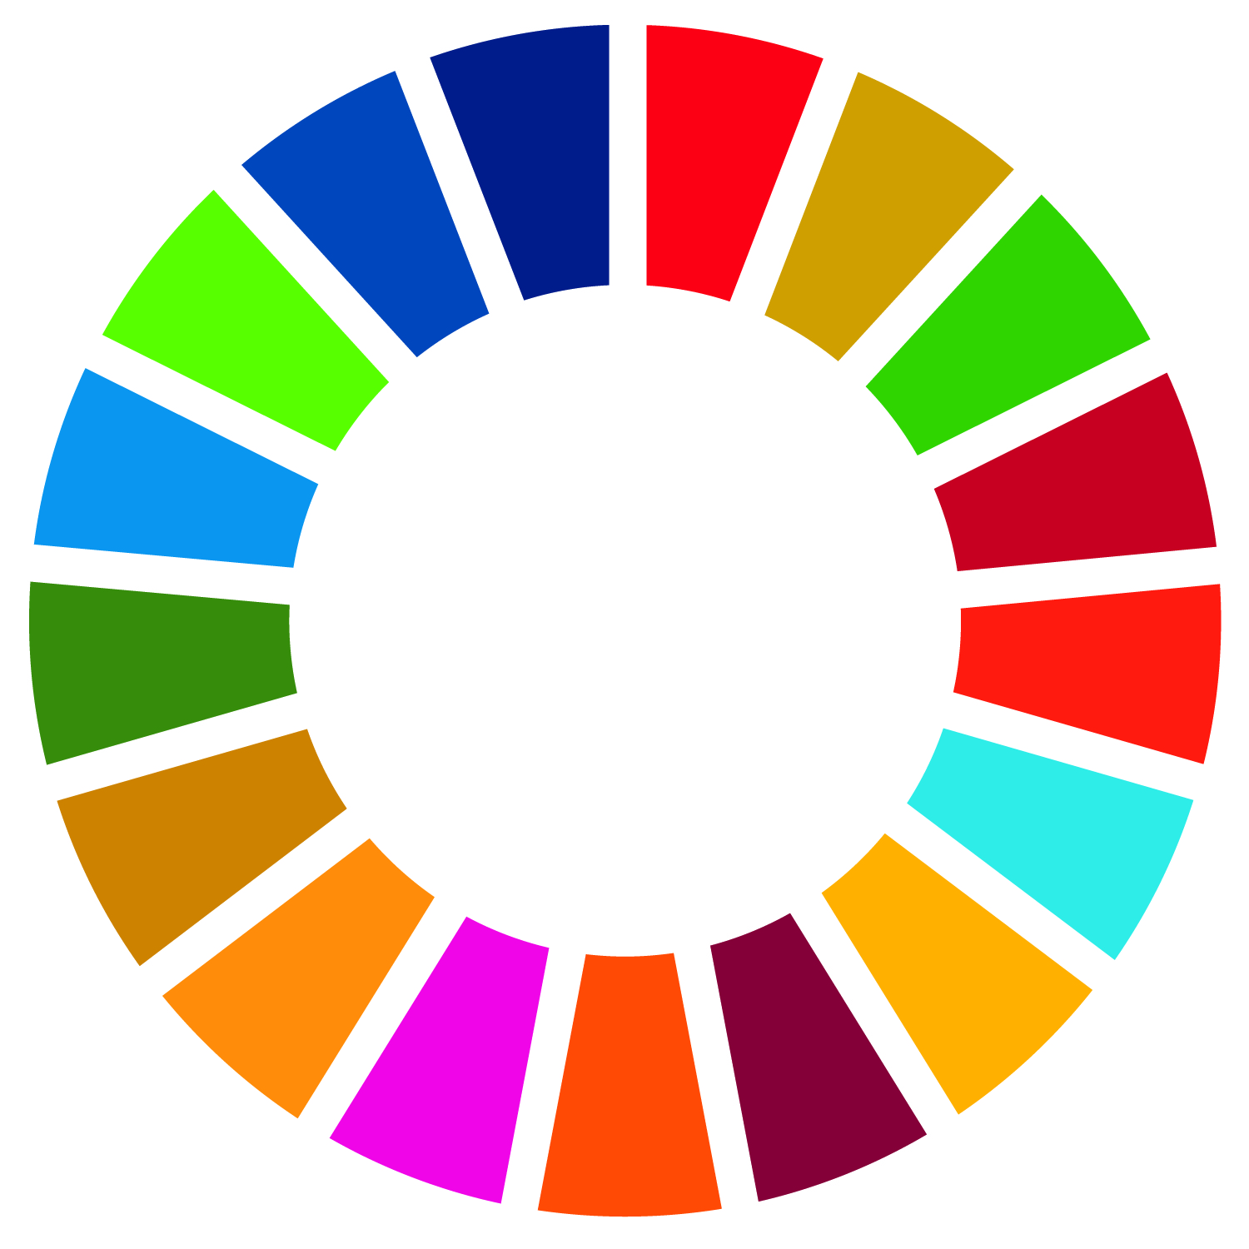

**Call for Proposals for**

**Seed Funding for Cooperation with the Global South 2024**

**I. Personal Information**

**Name of the applicant (Head of Chair)**

**Chair at Technische Universität Berlin**

**Email-Address Phone**

**2nd contact person at the Chair (if applicable)**

**Email-Address Phone**

**II. Cooperation with Partners in the** [**Global South**](https://www.oecd.org/dac/financing-sustainable-development/development-finance-standards/DAC-List-of-ODA-Recipients-for-reporting-2024-25-flows.pdf)

**With which partner(s) in the** [**Global South**](https://www.oecd.org/dac/financing-sustainable-development/development-finance-standards/DAC-List-of-ODA-Recipients-for-reporting-2024-25-flows.pdf) **do you intend to cooperate? Depending on the project proposal, partners can be Higher Education Institutions, research centers, NGOs or public institutions. Companies can be included as associate partners, however, travel expenses from company staff are not eligible for funding. The partners’ interest in the collaboration should be demonstrated by means of a letter of support.**

Please indicate information on your (possible) partner(s). Please insert rows as necessary.

|  |  |  |  |  |
| --- | --- | --- | --- | --- |
| **Name** | **Position** | **Institution** | **Department** | **Subject Area** |
|  |  |  |  |  |
|  |  |  |  |  |
|  |  |  |  |  |

**Please describe to what extent you have already established contact/collaboration (e.g. duration and level of contact, possible preceding collaborations of research, teaching or student supervision, etc.)**

1. **Proposal**

**Please describe shortly what research or cooperation you would like to initiate with regards to the Global South. About what subject or problem would you like to set-up your project?**

**(ca. 500 words)**

**For which activities do you apply for funding (e.g. field visits, invitation of partners, preparatory workshops)?**

**Does your proposal include the participation of young researchers at TU Berlin or the partner institution? If yes, please include further details:**

|  |  |  |  |  |
| --- | --- | --- | --- | --- |
| **Name** | **Institution and Department** | **Position and Career level** | **Nationality** | **Gender** |
|  |  |  |  |  |
|  |  |  |  |  |
|  |  |  |  |  |

**What budget are you applying for? Please fill in the details in the budget form (separate form) and state the total amount requested here**

**Total:**

1. **Reference to Sustainable Development Goals**

**Please indicate to which of the Sustainable Development Goals your project would relate and respond to and explain how.**

(Detailed information on the 17 goals and indicators can be found on: <https://sustainabledevelopment.un.org/sdgs>)

1. **Third-Party Funding**

**Where do you plan to submit your project proposal for third-party funding?**

1. **Other (as general feedback for the Team International Projects)**

**Do you already cooperate with (other) partners in the Global South? Which partner institutions in the Global South would you regard as your most important collaboration partner(s)?**

**Would you like to add any other remarks?**

1. **Application Documents**

* Application form, duly completed and signed by the applicant (Chair)
* [Budget form](https://view.officeapps.live.com/op/view.aspx?src=https%3A%2F%2Fwww.static.tu.berlin%2Ffileadmin%2Fwww%2F10004219%2FINT_IP%2FDokumente%2FSEED_FUNDING%2FSeed_Funding_Global_South_Budget_form.xlsx&wdOrigin=BROWSELINK) completed
* Letter of support from partner institution in the Global South

**Signature of the applicant (Chair TU Berlin)**

________________________

Date: