Supporting Information

Condition | Game type | P(B) | N | K
L1/3 | Lottery | 1/3
L1/2 | Lottery | 1/2
L2/3 | Lottery | 2/3
S-H K4 | Stag hunt |  | 10 | 4
S-H K7 | Stag hunt |  | 10 | 7
S-H K10 | Stag hunt |  | 10 | 10
S-H N2 | Stag hunt |  | 2 | 2
E K4 | Entry |  | 10 | 4
E N2 | Entry |  | 2 | 1
E K7 | Entry |  | 10 | 7
Table S1 List of conditions, game types and experimental parameters. P(B) is the probability of winning 15 euros given choice B in the lottery trials; N is the number of participants playing a game; and K is the number of players (“at least” in the stag-hunt, and “at most” in the entry game) that should choose B in the games in order to win.

Supplementary analysis
Playing games in groups of N=2. The frequency of B-choices (see Figure S1) decreased with increasing sure payoffs keeping other parameters constant (all logit functions are decreasing; regression analysis shows that the coefficients of the values of the sure payoffs (X) are negative for both conditions, p-value < 0.001). Participants made less B-choices in the stag-hunt games when playing in groups of ten vs. two players (p-value < 0.001). In the entry game, B-choices for N=2 are not significantly different than for N=10 (K=4) (p-value = 0.98), while B-choices are significantly lower for N=2 compared to N=10 (K=7) (p-value < 0.001). The data of the conditions N=2 confirm the differential pattern of behavior observed between the entry and the stag-hunt game for RL and RA, thus RA participants chose less often B in the stag hunt compared with RL participants (p-value = .03), while in the entry game we did not find any significant difference between the two groups of participants in terms of B-choices (p-value = .41). Behavior in playing games with N=10 and N=2 was strongly correlated (e.g., cross-subjects correlation of B-choices in entry N=2 and entry N=10 K=7: rho = .63 p-value .0049 Bonferroni adjusted significant level, and rho = .80 p-value = .0001 with entry N=10 K=4; and stag hunt N=2 and N=10 K=7 rho = .57 p-value = .013). Finally, at the brain level, we did not find any differential activity between the conditions N=2 vs. N=10. We performed a conjunction analysis of the contrast N=2 vs. N=10 in the stag-hunt and entry games. We created a design matrix containing 10 regressors (i.e. one for each condition): BOLD = b0 + b1 lottery-L 1/3 + b2 lottery-L 1/2 + b3 lottery-L 2/3 + b4 stag hunt-N10 K4 + b5 stag hunt-N10 K7 + b6 stag hunt –N10 K10 + b7 stag hunt-N2 K2 + b8 entry-N10 K4 + b9 entry-N2 K1 + b10 entry-N10 K7 + ε. We performed a conjunction analysis of two contrast vectors: λN2-stag hunt = [0, 0, 0, -1, -1, -1, 3, 0, 0, 0], and λN2-entry = [0, 0, 0, 0, 0, 0, 0, -1, 2, -1]. No differential activity was found (even with a very liberal threshold, p<0.001 uncorrected) between playing N=2 vs. N=10. We thus merged the data of the condition with N=2 with the other conditions for the fMRI analyses reported in the manuscript.
The independence between the measure of risk (certainty equivalents) and the measure of strategic sophistication in games. When considering only threshold-strategy players (N=10, the categorization of threshold and non-threshold players was based on choice data from the entry games), we found a significant correlation across subjects between certainty equivalents (the estimated X*) for the lotteries and the stag-hunt games (Pearson correlation, rho=0.8085, p-value .0083 Bonferroni-adjusted significance level); no-significant correlation between lotteries and entry games (rho=0.4974, p-value = .26); and no-significant correlation between entry games and stag-hunt games (rho=0.1815, p-value=.67). Thus, confirming the behavioral pattern observed with the entire sample of participants (X*-lottery and X*-stag hunt: Pearson correlation r = 0.69, p = 0.0019, Bonferroni-adjusted significance level; X*-lottery and X*-entry: r = 0.27, p = 0.33; and X*-stag hunt and X*-entry: r = 0.22, p = 0.41). This finding supports the hypothesis of independence between threshold strategies in the entry game (as a measure of strategic sophistication) and behavior in the lotteries and stag-hunt game. Moreover, there was no significant difference in terms of risk preferences (estimated certainty equivalents for the lottery) between threshold and non-threshold players (Two-sample Wilcoxon rank-sum test, z=0.78, p=0.70). Thus, confirming the independencey between the measure of risk and the measure of strategic sophistication.

Supplementary figures

Figure S1: Relative frequencies of B choices separately for stag hunt, and entry games conditional on the (21 different) sure payoffs for groups of N=2.

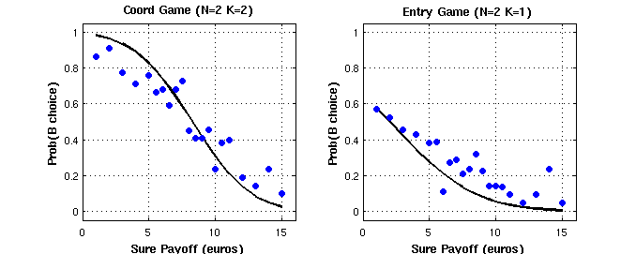

Figure S2: dmPFC activity resulting from GLM 1 (red), GLM2 (green) and overlap (yellow).

