Checklist to publish your online dissertation

(The list can be found here in English: https://www.ub.tu-berlin.de/en/publishing/publish/checklists-for-publishing-dissertations/checklist-to-publish-your-online-dissertation/

In German: https://www.ub.tu-berlin.de/publizieren/veroeffentlichen/checklisten-zur-veroeffentlichung-von-dissertationen/dissertationen-online/)
All notes written in orange were added by Anika Bockisch, Jan. 2019/April 19
- After the thesis defense (“Disputation”) please prepare the 'approved version' of your thesis. Decide, whether the research data of your thesis (e.g. measurement and survey data, laboratory values, audio-visual information, texts, software or simulations) should also be archived by TU Berlin and thus can be cited and re-used.
Copyright information (German)
FAQ: Research Data (German)
Guideline for Research Data

- Please insert a title page before your text as is required by TU Berlin regulations.
Title page template (PDF, 77 KB)
  - Attention!, do not take examples from other colleagues, since this might change during the years. Check on the website.
  - The field „geb. am“ on the front page has been replaced with the author‘s ORCID number after March 2019.

- Prepare the document for publishing.
Guideline for creating PDF/A or PDF/X files (PDF, 4,7 MB)
  - Please cancel your CV in case you had included it for the reviewers (data protection).
  - The declaration of originality can be deleted as well, since you have to sign extra documents at the faculty considering this point.
  - When saving your Word-File as a PDF, please activate: “setting text marks using headings (see screenshot)”. Format the title page and abstract / “Zusammenfassung” as headings as well in order to include them in the book marks in your PDF file.

  - Check that the zoom settings are on standard during PDF conversion.
  - Check picture compression during PDF conversion.
  - After PDF conversion check your document for PDF/A compatibility see 7. in Guideline for creating PDF/A or PDF/X files
PDF/A optimization and postprocessing (PDF, 1.9 MB)
- General: Please do not take older dissertations from our chair as an example, since it was not controlled for everybody before publishing – especially regarding the properties of the PDF file.
- Property settings:
  - Description (see also following screenshot):
    - Title: Put the same as written in the thesis (in meta data written in small letters though, see 5.).
    - Topic: Dissertation; DCC class:
please go up to the 3rd level when entering your meta data (see 5.). Then copy ONLY the last level and insert it in the point Description Topic, e.g.: DDC 620: Ingenieurwissenschaften und zugeordnete Tätigkeiten.
Please set a colon „:“ in between!
    - Keywords must be the same as given in the meta data (see 5.). Should be separated by a comma, all English key words have to be written in small letters apart from proper names. German translation according to German grammar.

  - Security, fonts, initial view: see screenshots in PDF Document “UV_pdfaPostDE/ENG”
  - In additional information: Enter in the field “language” the language, in which your text is written, not the language properties of your document.
- Bookmarks:
  - The title page as well as abstract / “Zusammenfassung” must be included in the book mark list.
  - Note that the book marks – when set manually – will be set where the cursor is currently located It might not be the best view for linking. Scroll to the right view when setting the marks and check afterwards.
Also close the tools window while setting manually in order to have the full screen available.

- Log on to DepositOnce, the repository for research data and publications of TU Berlin. This requires a registration with your TU-account. In case you do not have a TU-account or in case of questions, please contact us.
Register
Login
Contact
If you are an external doctoral candidate: please ask Mrs Kühn or Mrs Kruse via email (dissertationen@ub.tu-berlin.de) for a tubIT-Account. You need this to get access to DepositOnce!!!

- Submit the metadata and your file(s) to DepositOnce by completing the form "publish". Follow the instructions and provide as accurate information as possible.
- Choose: Fak III publication doctoral thesis.
- Please write all English words – except proper names - in the meta data in small letters (also the title).
- Do not forget to insert the title, keywords, and the abstract in English AND German.
- Follow the instruction for each input field, note:
  - License: add the information that you have chosen in the license document (page 3).
  - DCC class: go into the 3rd level, cancel the second colon, which appears automatically e.g. for engineering at our department it would be: “DDC:600 Technik, Medizin, angewandte Wissenschaften:620 Ingenieurwissenschaften:620 Ingenieurwissenschaften und zugeordnete Tätigkeiten”

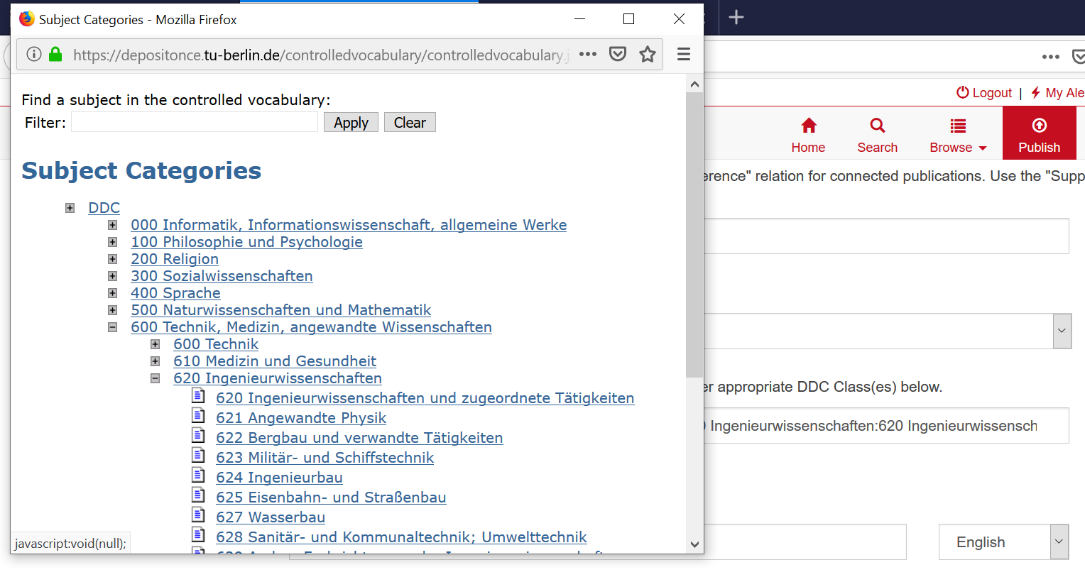

  - Keywords: max. 5, short
  - Extra description/internal note: not necessary
  - Advisor: first supervisor (usually Prof. Neubauer)
  - Referees: all reviewers (“Gutachter”), including first supervisor (usually Prof. Neubauer)
  - Abstract (de/eng) --> copy & paste from your dissertation
  - Sponsor/founder: add according to your founding project (might be adapted by university later)

Carefully check the form „Deposit License“ that is filed at the end of the submission process and sign it.
a Deposit license (unofficial English translation) (PDF, 225 KB)
Deposit-Lizenz (official German version) (PDF, 242 KB)
Open access is the preferred version. However, in the cumulative case you must check carefully with all co-authors and the journals where you published your articles.

- The Dissertation Office checks your submission and will contact you. After you got our confirmation you can prepare 1 printed copy of your dissertation*:
The allowed formats are DIN A4, DIN A5 and intermediate formats. Pages can be printed on one or both sides. Please use white, age-resistant paper. The copies must be permanently bonded. Ring or spiral binding are not permitted.
- Here, you can use a glue binding, there is no must to deliver a version with a self-created cover as required at the chair of Bioprocess engineering (Prof. Neubauer) special soft cover costs nearly the double.

- Please submit the printed copy and the Deposit License to the Dissertation Office (University Library). You may authorize another person to submit the documents or use postal services.

- The Dissertation Office checks the submitted documents for compliance with the requirements and issues an acknowledgement of receipt, which serves as the basis for the issuance of the doctoral certificate by your faculty.
The receipt is handed over to you directly when you submit the printed copy personally in the library. Otherwise it is delivered by post as registered post “Einschreiben”.
Then send / bring this receipt together with the “Bestätigung über die bei der Aussprache vereinbarten Änderungen” (signed by your direct supervising professor) to the faculty III management (Mrs. Neumann). After about 3 weeks you will get an information (again by registered post) that you can pick up your certificate.

*Some service providers can help you to produce the hard copy and, if needed, assign an ISBN number for your publication, while still allowing distribution under a Creative Commons license.

Contact to the publishing office at TU library:
Website: http://www.ub.tu-berlin.de/dissertationen/
https://www.ub.tu-berlin.de/en/publishing/dissertation-office/
Address: Fasanenstr. 88, room 139, 10623 Berlin
(you have to register at the porter lodge to enter)
Email: dissertationen@ub.tu-berlin.de
Contact persons:
Barbara Kühn
Tel.: (030) 314 - 76129
Jutta Kruse
Tel.: (030) 314 – 76128, Fax: (030) 314 - 76133

Phoning (and mailing) at any working hour possible.
Personal contact only during consulting hours: Mo. - Fr. 10:00 - 13:00 am

