Further Information – Writing a Bachelor/Master Thesis at the Department of Bioprocess Engineering

- Discuss the scope and time frame of your thesis with your supervisor at the beginning.

- Both the student and the supervisor should use the first weeks of the induction to see if they are on the same wavelength and if the topic is really what they want in order to avoid losing valuable time. This can be seen as a kind of trial period.

- Communication is essential!

- Schedule regular meetings with your advisor to go over results, discuss problems and the next steps.
  - This is science and plans may change! Make adjustments together on time.
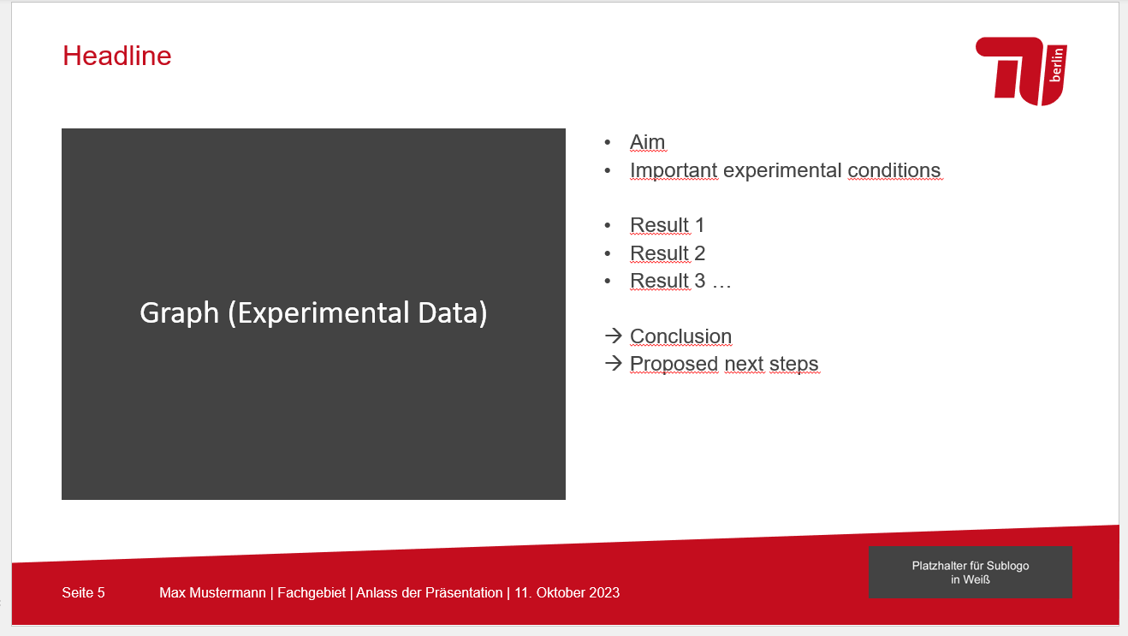
  - Preparing a short PowerPoint may help to get an overview over the current results and status of your thesis. Prepare figures and add the main results/conclusions as key points next to it. (This does not have to be exceptionally pretty!)

- If you plan to start writing the thesis, go over the planned structure/content/results with your advisor before you start. You can use the guidelines and template available on the BVT website. There is also a file on graph building requirements and the layout for your final presentation.
  - Registration of your thesis: fill the form from the Prüfungsamt without title (first supervisor is Peter Neubauer, see thesis template). Before submitting the form agree on a title with your supervisor. Once you have a title send an email to Peter with your supervisor (and maybe advisor as well) in cc and let him know that you will register your thesis at the Prüfungsamt and state the chosen title.

- If you want your advisor/supervisor to give feedback on your thesis before your submission deadline, please keep in mind that a few weeks are needed in advance to give fruitful advice and corrections. You will also need time to incorporate all changes. Discuss this with your advisor. It makes sense to send your thesis chapter by chapter.

- All acquired data must be neat and comprehensible and made available to your advisor before you leave the department.

